**General Chemistry LabII-1112L**

# Lab Report#___12___

Andrew Kalathra, Department of Chemistry and Biochemistry, Lamar University, Beaumont TX 77710

**Title- Redox Reactions in Voltaic Cells**

**Objective**- Explore the components of a battery and make one. Also see the effect on ion concentration.

**Procedure-**

* 1. First, we collected our materials for our first procedure. This included getting a solution of NH4NO3 to dip our 7 thinly cut paper towels, 3 vials ¾ filled with .2 M Zn, Cu, & Al solutions, Cu Zn, and Al metal strips/wires, and steel wool.
  2. We kept each metal solid bent over their respective solutions and began our first experiment.
  3. We first made a salt bridge between the Zn and Al solutions via the paper soaked in our NH4NO3 solution. We then connected the alligator clips to read a positive value on our LabQuest voltage display. We recorded the voltage.
  4. We repeated this experiment for Zn and Cu, as well as for Cu and Al. This was the end of our first procedure.
  5. Ous second procedure required us to use our Cu and Zn solutions with the metals, as well as make a .02 M solution of both the Cu and Zn solutions, and a .002 M solution of Zn.
  6. We then repeated the steps from procedure 1, but the combinations were as such (all were Zn and Cu respectively): .2 M:.2 M; .02 M:.2 M; .002 M:.2 M; .2 M: .02 M.
  7. We recorded the voltages, and finally finished our last procedure of GenChem 2.

**Data and Results**

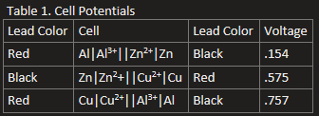

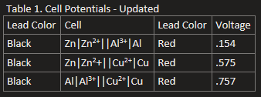

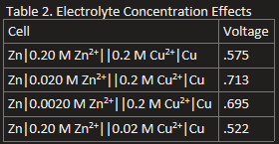

**Conclusions**

Overall, this was a relatively simple and fun lab. We got to explore how different solutions and their metals transfer electrons. We also got to learn the parts of a battery, how they work, and how to build one. We got to calculate the voltages of our own batteries using our voltage probe. Our results were not bad, but they could have been more accurate had we caught what the highest voltage was for each reaction. The probe, as said in the note, did not stabilize for any of them, which threw us off, but we managed to get some decent data. This was a great lab and a great semester.

**Key Questions-**

**1. What type of electrochemical cell does your team think a battery represents? Why did your team make that decision? -** Out of the two options defined, I think a battery is a galvanic cell because they do not require an outside application of voltage.

**2. What is oxidation? What is reduction? -** Oxidation is the loss of electrons, and reduction is the gain of electrons.

**3. The reaction Zn(s) + Cu2+(aq) → Zn2+(aq) + Cu(s) can be separated into two half reactions, one an oxidation reaction and the other a reduction reaction. What are those two half reactions?**

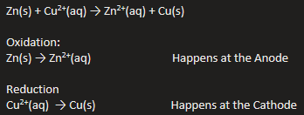

**4. In an electrochemical cell, which of the half reactions in the question above will occur at the cathode and which at the anode?**



**5. What was the ionic bridge between the half cells? -** Our thin paper towel soaked in NH4NO3 served as a fine ionic bridge.

**6. When a positive voltage was obtained, what type of cells were constructed? -** Voltaic Cells

**7. The cell reactions in Table 1 may or may not have been written in the correct convention (anode to the left). The voltage probe will produce a positive voltage when the black clip lead is connected to the anode and the red clip lead is connected to the cathode. Identify which cell reactions in Table 1 are written in the correct order and then correctly rewrite any of them that were in the incorrect order. (Shift \ gives the | symbol on US keyboards.) -** The first and third row of the table were mixed up, this is the updated table:



**8. Why is it possible that the anode in one cell can be the cathode in another cell? -** It depends on the reduction potential of each reactant. The lower the reduction potential, the easier it would be to reduce, which would mean it would react at the cathode.

**9. Based on the overall reaction that occurs in the galvanic cells in Table 2, which chemical species are the products and which are the reactants? -** The reactants would be Zn and Cu2+, while the products would be Zn2+ and Cu.

**10. What would be the equilibrium expression for the overall reaction above? -** 

**11. Based on the measured voltages in Table 2, what was the effect of reducing the reactant ion concentration? What was the effect of reducing the product ion concentration? -** For us, reducing the reactant concentrations would also decrease the voltage, but reducing the product concentration increased the voltage.

**12. Based on these observations, what should be the effect on the cell voltage by increasing the concentration of the reactant ion? What should be the effect on the cell voltage by increasing the concentration of the product ion? -** Assuming the question above was correct, increasing the reactant concentration should increase the voltage, but increasing the product concentration should decrease the voltage.

* Do not forget to attach the signed lab work-out

